**Docker Image to Run Test Cases**

**Prerequisites:**

1. **Docker Desktop:**

* Windows 10 Pro, Enterprise, and Education:

<https://docs.docker.com/docker-for-windows/install/>

* For Windows 10 Home:

<https://docs.docker.com/docker-for-windows/install-windows-home/>

1. **Git(if required)**

* GitBash Installation for windows:

<https://git-scm.com/download/win>

**To run the test cases in a Docker Container(testing-server), please follow the steps below:**

**Step - I**

* 1. Unzip the given ‘**test-project-docker_powershellScript_20201229_working_folder’** folder.

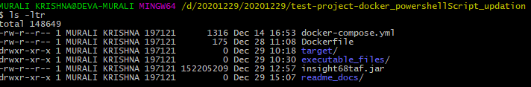

* 1. Go to ‘target/’ folder and edit the ‘remoteURL’ and ‘zapaddress’variables with local ip-address in ‘configuration.properties’file. Refer to the following table:

|  |  |
| --- | --- |
| **Property** | **Value** |
| *androidRemoteURL* | Change this variable with local ip address to connect with appium and android emulator. |
| *remoteURL* | Change this variable with local ip address connect withthe chrome driver url. |
| *zapaddress* | Change this variable with local ip to connet to zap server. |
| *qaURL* | Change this variable to connect with testing server url(subscription application url). |
| *mailReceivedUser* | Change this variable with any email id to receive testing reports after completion of tests. |

**Example(refer to the below image):**

Edit the ‘remoteURL’ variable with your local IP Addressin ‘configurations.properties’ file.

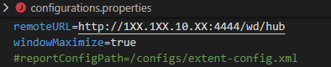

**Step – II**

1. Execute two power shell script present in “executable files” folder one by one:

- First execute “sdk_install” - Right click on sdk_install and select “Run with powershell”, emulator will spin up.

- After emulator is up and running, execute “apk_install” - Right click on “apk_install” and select “Run with powershell”

**(or)**

- Right click on “click_sdk_install” and Select “Run as administrator”

- After emulator is up and running, Right click on “click_apk_install” and Select

“Run as administrator”

**(or)**

- Run powershell in administration mode and execute “.\sdk_install” and .\apk_install” one-by-one.

After executing make sure emulator and testing containers are up . Please refer below pics:

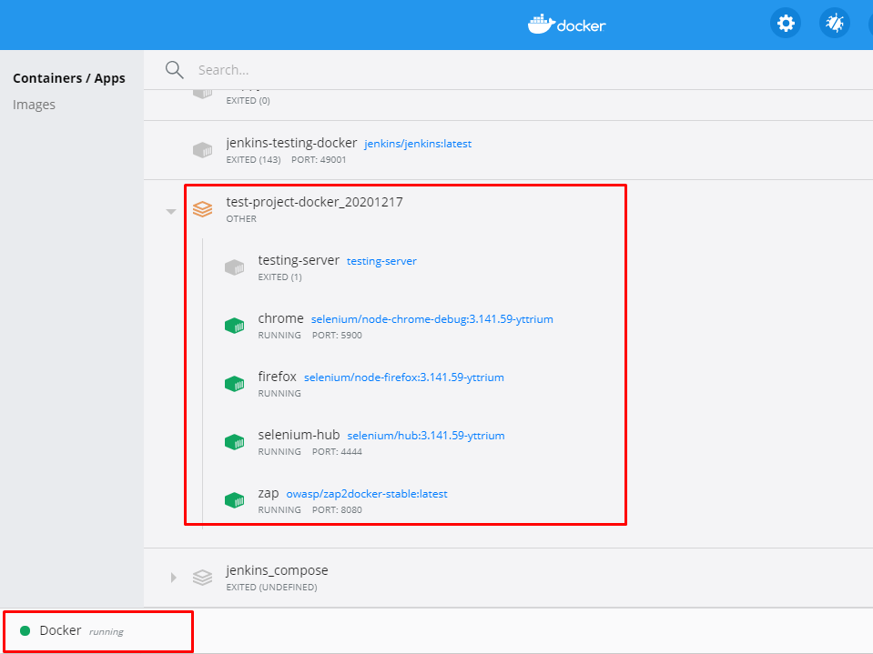

Make sure Docker is running and contains all containers.

2.

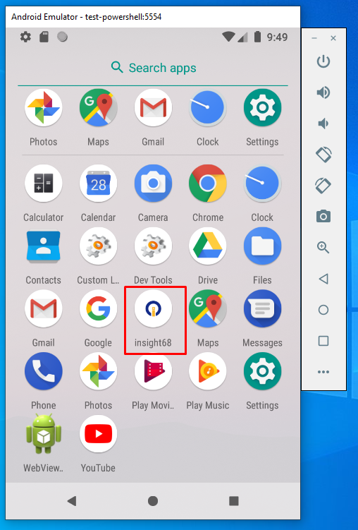

Check Emulator is up and running with apk file installed.

3. Run below command:

- “**docker container run -it testing-server bash**” to get into the testing server.

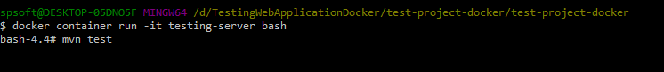

- And run **“mvn test”** and check the email for reports.

Test reports are generated and are sent to the given email-id value in “*mailReceivedUser*” variable in the *configuration.properties* file.

